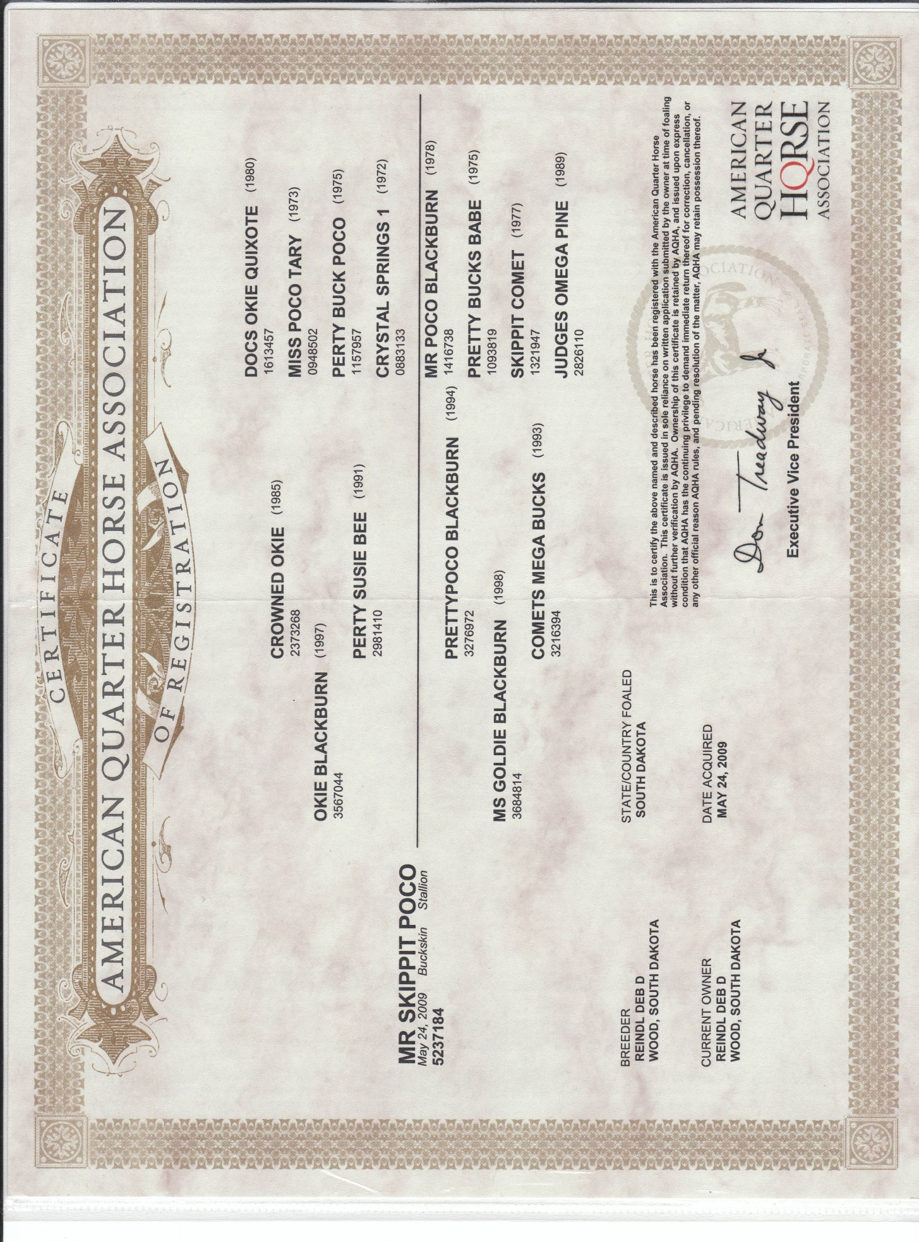

C:\Users\Owner PC\Pictures\HORSE PICTURES\Stallions\Skippit\REG-GENETIC TESTING RESULTS - 5237184 - MR SKIPPIT POCO (6163466) -.tif